**Implementation Steps for Analysing the Data:**

**Tech Stack used:**

1. Azure Data Factory
2. Azure Data Bricks with Python
3. Azure synapse

**1. Azure Data Factory:**

**1.Create Storage Account/ Containers:**

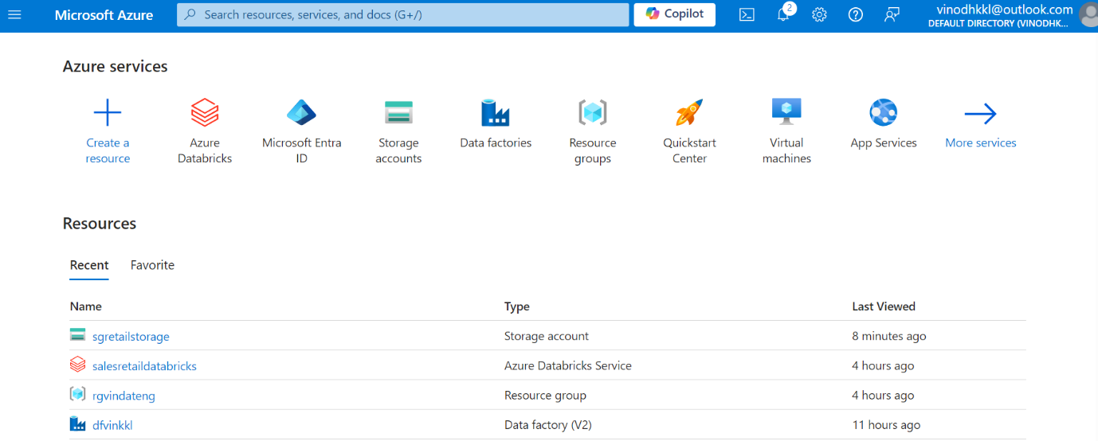

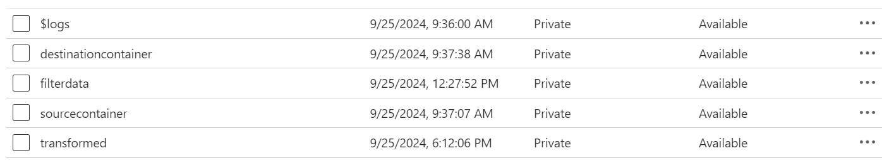

**2.Create DataFactory:**

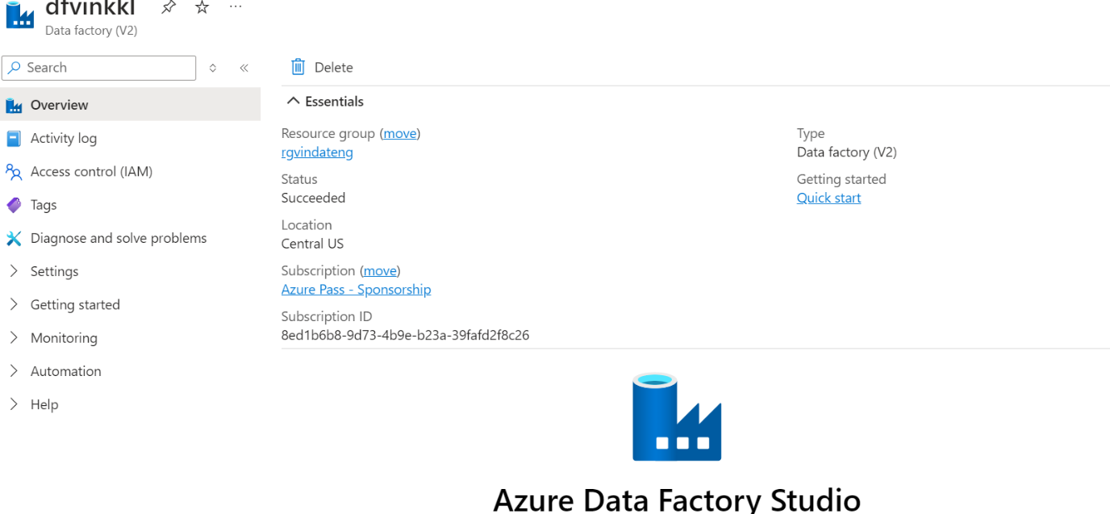

**3. Use Copy data Activity for copying data from Source to Destination:**

1.Create Azure DataFactory.

2.Create Dataset for Source and Destination

3.Create Pipeline to execute copy data activity

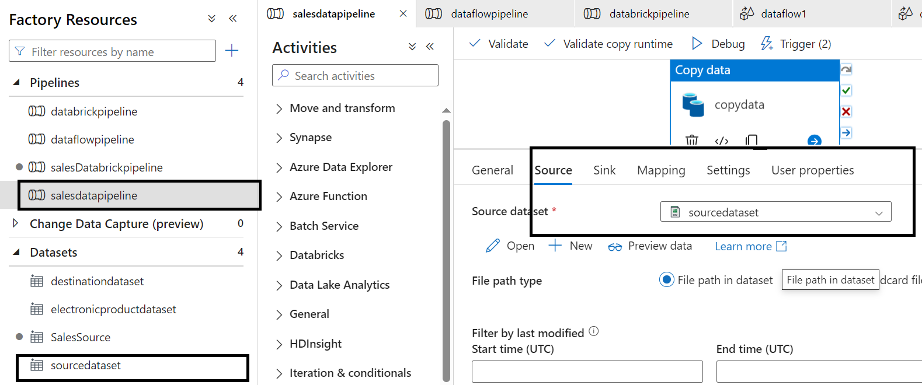

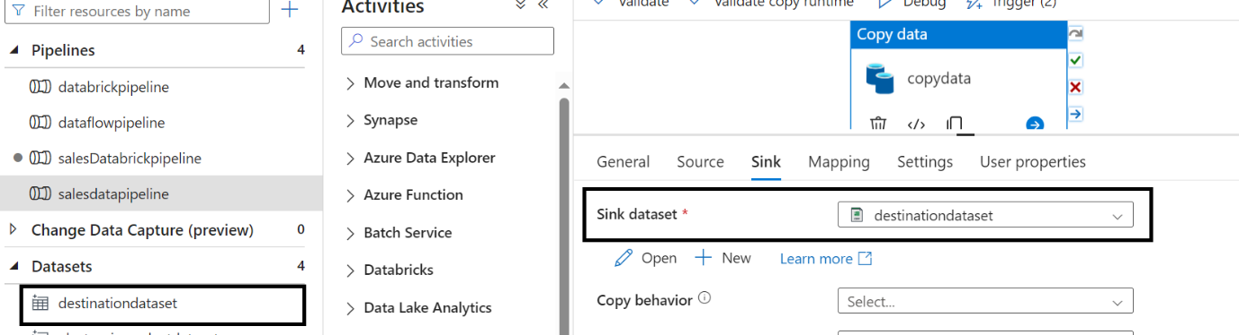

**4.DataFlow:**

Doing some Transformation using Dataflow Activity

1.Create Dataflow activity

2. Use source and sink to be the Mandatory for the Dataflow

3.Use filter and Select Formatter for Transformation

4.Create pipeline to execute the Dataflow activity

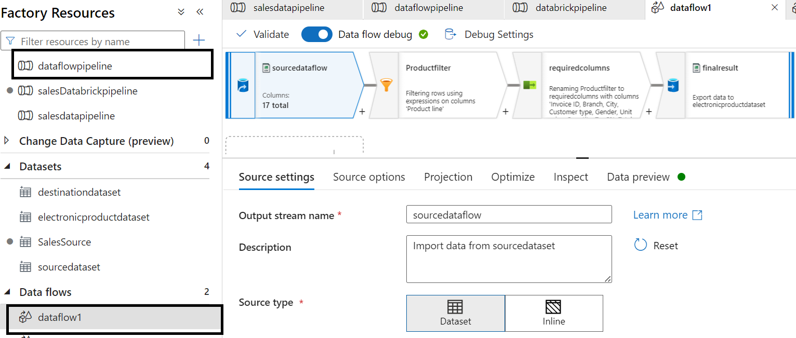

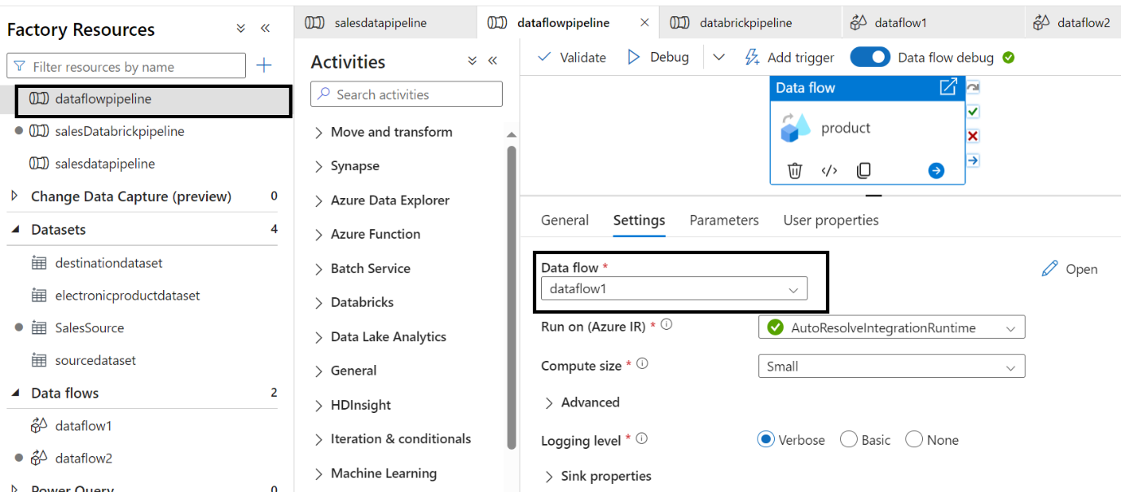

**2.Azure Data Bricks:**

**1.Create Linked service:**

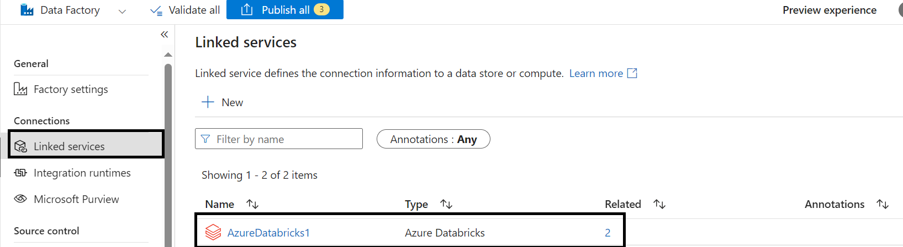

**2.Create Notebook Activity and config the DataBricks and add in the Pipeline:**

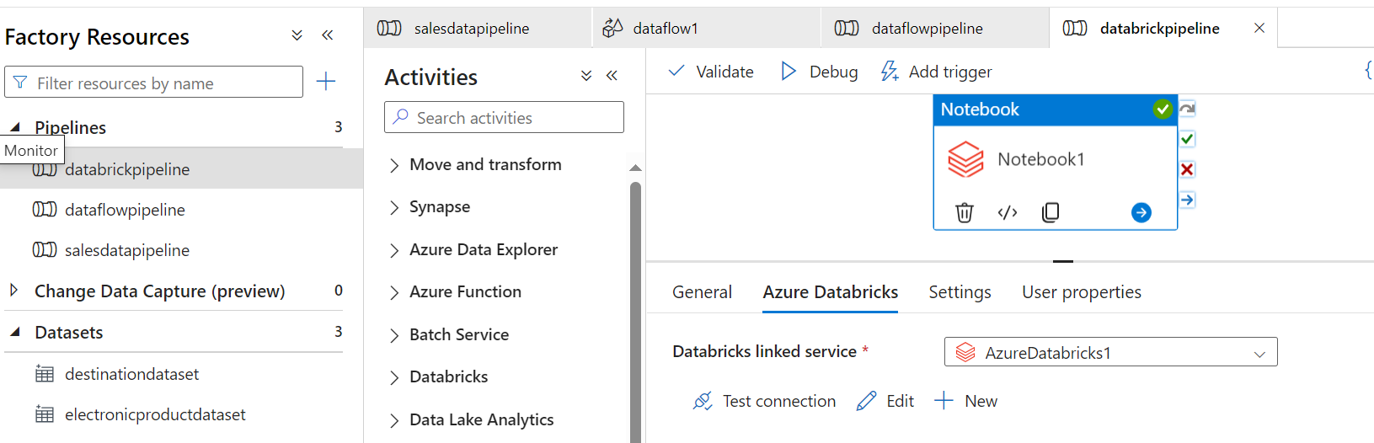

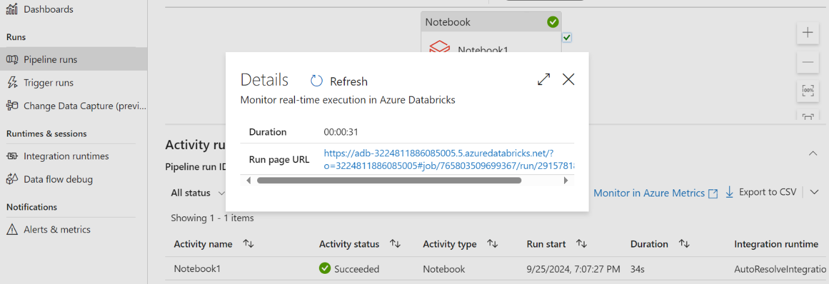

**3.Data Bricks Link:**

<https://adb-3224811886085005.5.azuredatabricks.net/?o=3224811886085005#notebook/3411316132355740/command/3411316132355741>

**4.Monitor Pipeline:**

**3.Azure synapse:**

**1.Synapse Workspace:**

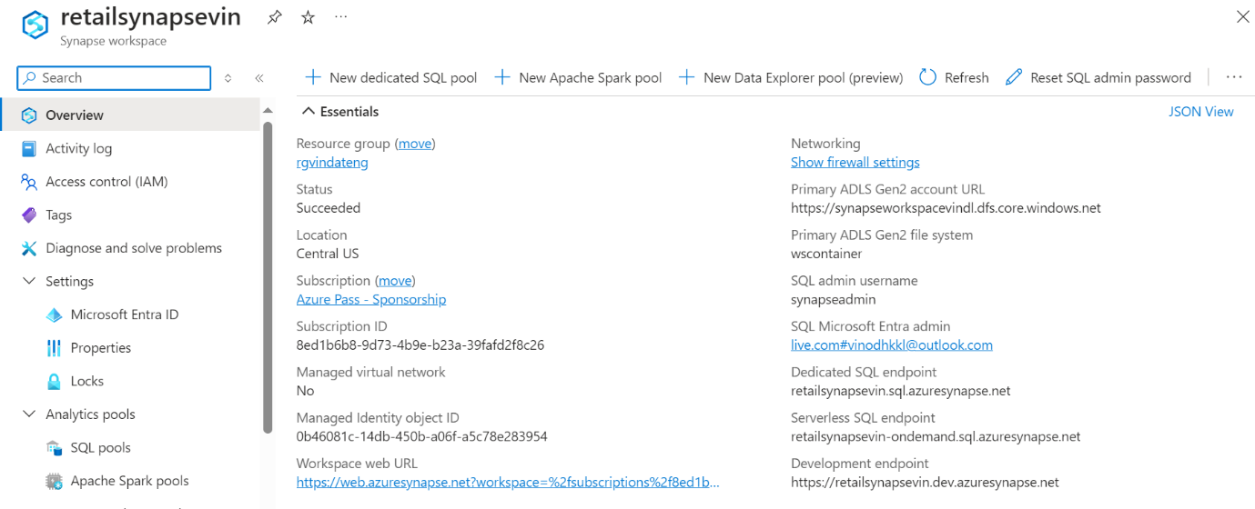

**2.Dedicated Pool:**

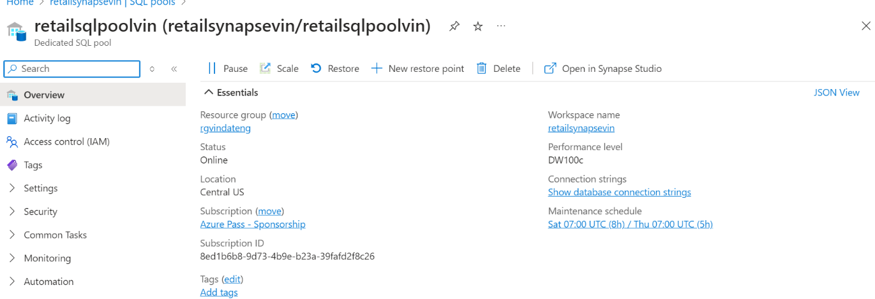

**3.Synapse Studio:**

